Introduction to Linear Algebra and Its Applications in Data Science
1. Overview
Linear Algebra is one of the foundational mathematical subjects behind Data Science, Machine Learning, Deep Learning, NLP, Computer Vision, and AI.
At its core, linear algebra gives us tools to represent and manipulate numerical data using objects such as:
- Scalars
- Vectors
- Matrices
- Linear transformations
- Systems of linear equations
- Eigenvalues and eigenvectors
The lecture emphasizes that these are not just abstract mathematical concepts. They are used internally when ML models represent data, perform calculations, train neural networks, reduce dimensions, process images, and optimize model parameters.
Big picture:
Real-world data → numerical representation → vectors/matrices → mathematical operations → ML/AI computation

2. Why Linear Algebra Matters in Data Science
Linear algebra has applications in many areas, including physics and mathematics. However, this course focuses on its importance from a Computer Science + Data Science perspective.
It becomes especially important because modern datasets often contain many features, meaning they can have very high dimensionality.
For example:
- A simple dataset might have 2 features.
- Another dataset might have 20 features.
- An image may contain thousands or millions of numerical values.
- An ML dataset can contain hundreds or thousands of features.
- NLP and modern AI systems represent text using high-dimensional vectors.
Linear algebra provides efficient ways of working with this high-dimensional numerical data.
ML Importance: ⭐⭐⭐⭐⭐ Very High
A strong understanding of linear algebra will eventually help you understand:
- Linear Regression
- Logistic Regression
- PCA
- Neural Networks
- Deep Learning
- Embeddings
- Computer Vision
- Optimization
- Many ML research papers
The lecture specifically identifies vectors, matrices, matrix operations, linear transformations, eigenvalues, and eigenvectors as important foundational topics.

3. Core Terminology
Before going deeper, understand these terms.
Term | Simple Meaning | Importance in ML
Scalar | A single number | Represents individual numerical values
Vector | An ordered list of numbers | Represents data/features
Vector Space | A mathematical space containing vectors and operations on them | Foundation for representing data
Matrix | A rectangular arrangement of numbers | Stores datasets, weights, transformations
Linear Equation | An equation involving variables to the first power | Used in models such as linear regression
Linear Transformation | A transformation that maps vectors while preserving linear structure | Used in PCA and graphics
Eigenvalue | A value describing how a transformation scales a special direction | Important in PCA
Eigenvector | A special direction that remains unchanged in direction under a transformation | Important in PCA
The lecture introduces these concepts as the foundation of the upcoming linear algebra series.

4. Application 1 — Data Representation and Manipulation
What is the problem?
Suppose we have a house price dataset.
We want to build an ML model that predicts the price of a house.
Our dataset may contain:
Area | Number of Rooms | Location | Price
1200 | 2 | Bangalore | ₹45 lakh
... | ... | ... | ...
Here:
Input / Independent Features
- Area
- Number of rooms
- Location
These are the features given to the model.
Output / Target Feature
- Price
This is what the model tries to predict.
The lecture uses this house-price example to explain how real-world information gets converted into numerical representations that an ML model can process.

Why can't the model simply understand the data?
A human can intuitively reason:
Larger house + more rooms + desirable location → probably higher price.
But an ML model does not inherently understand the concepts of:
- "house"
- "Bangalore"
- "large"
- "expensive"
It works with numerical representations.
Therefore, the information must be converted into numerical form.

5. Vectors for Representing Data
What is a vector?
In this context, a vector can initially be thought of as:
An ordered list of numbers representing information.
For example:
$$x=\left[\begin{matrix}1200 \\ 2\end{matrix}\right]$$
This vector represents two features:
- 1200 → area
- 2 → number of rooms
If we add another numerical representation for location:
$$x=\left[\begin{matrix}1200 \\ 2 \\ \text{location representation}\end{matrix}\right]$$
The location itself must eventually be represented numerically before being supplied to a mathematical model.
The lecture introduces vectors at this basic level and notes that the detailed study of vectors comes later.
Important
A vector is not simply "a collection of numbers" in every mathematical context. More precisely, it is an ordered mathematical object whose components can be operated on according to vector-space rules.
For now, however, thinking of a vector as an ordered list of numerical features is exactly the useful intuition for Data Science.

6. Dimensions of a Vector
The dimension of a vector refers to the number of components/features it contains.
1-dimensional vector
$$x=\left[1200\right]$$
It contains one value.
Therefore:
$$\boxed{\text{Dimension}=1}$$

2-dimensional vector
$$x=\left[1200 , 2\right]$$
It contains two values:
- Area
- Number of rooms
Therefore:
$$\boxed{\text{Dimension}=2}$$

3-dimensional vector
$$x=\left[1200 , 2 , \text{location}\right]$$
Now there are three components.
Therefore:
$$\boxed{\text{Dimension}=3}$$
The lecture illustrates this progression from one feature to multiple features and connects vector dimension with the number of represented features.
Key relationship
Number of features → Dimension of the feature vector
For example:
$$500\text{ features}⇒500\text{-dimensional feature vector}$$

7. Vectors and Coordinate Systems
When we have a 2-dimensional vector, we can visualize it using a 2D coordinate system.
Suppose:
$$x=\left(1200 , 45\right)$$
where:
- $x=1200$→ area
- $y=45$→ price
We can represent this as a point on a graph.
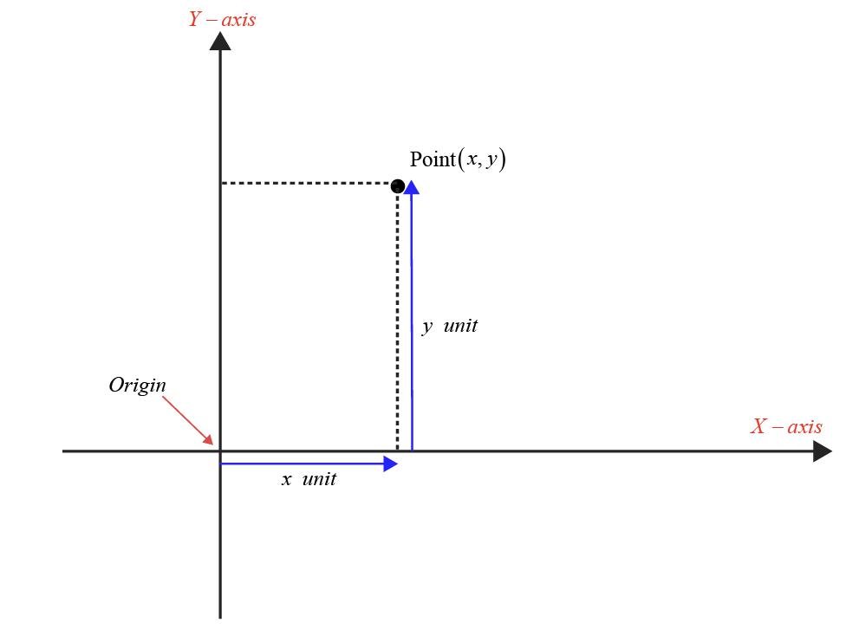
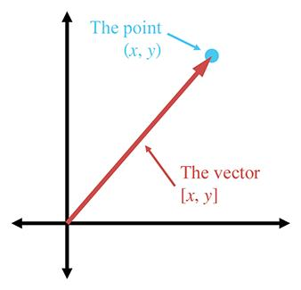
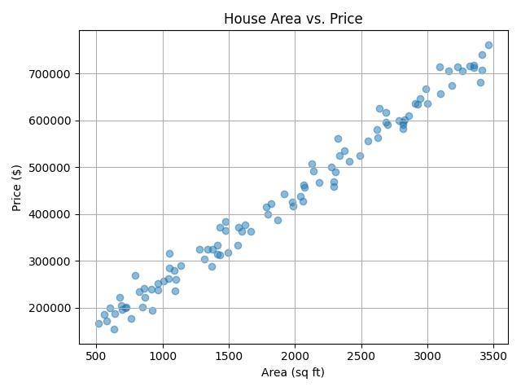
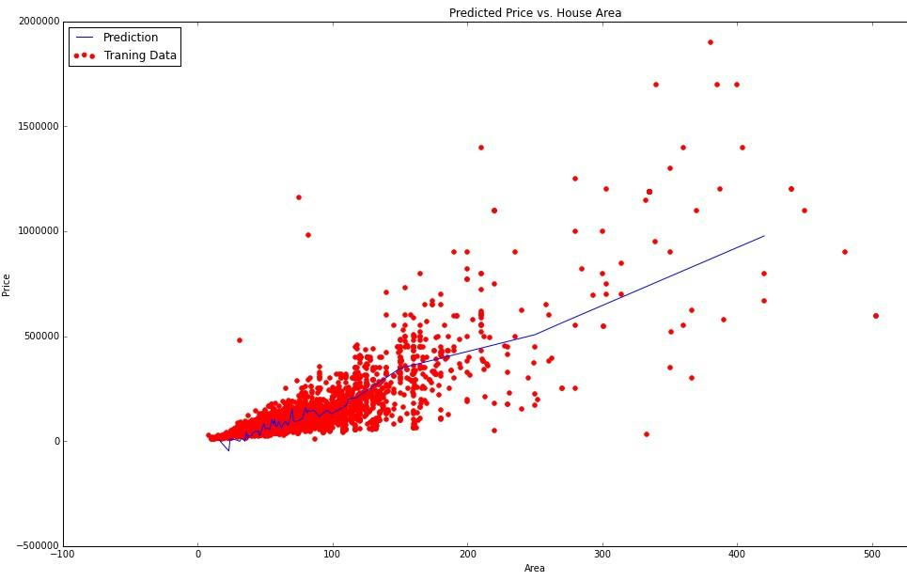
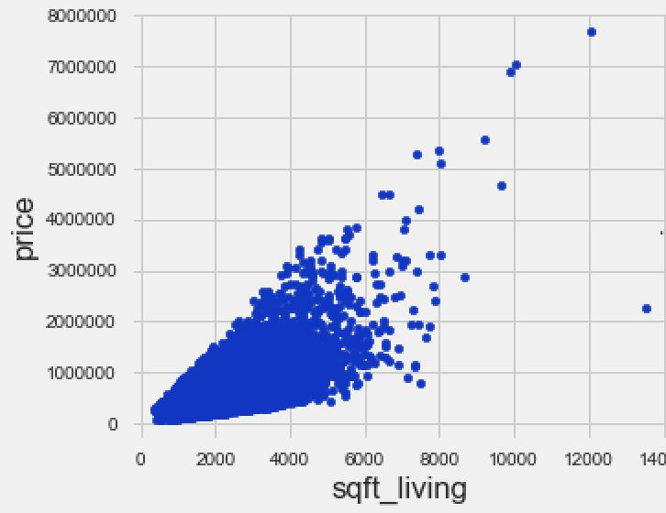
The point
$$\left(1200 , 45\right)$$
represents one observation.
If we have many houses, we get many points.
For example:
$$\left(800 , 30\right), \left(1000 , 38\right), \left(1200 , 45\right), \left(1500 , 60\right)$$
These points form a dataset in a 2D feature space.
The lecture explicitly explains that each point can represent a vector, with its coordinates corresponding to the feature values.

8. Three-Dimensional Data
Suppose we have three features:
- Area
- Number of rooms
- Price
Then one observation could be represented as:
$$x=\left(1200 , 2 , 45\right)$$
This can be visualized using three axes:
- $x$→ Area
- $y$→ Number of rooms
- $z$→ Price
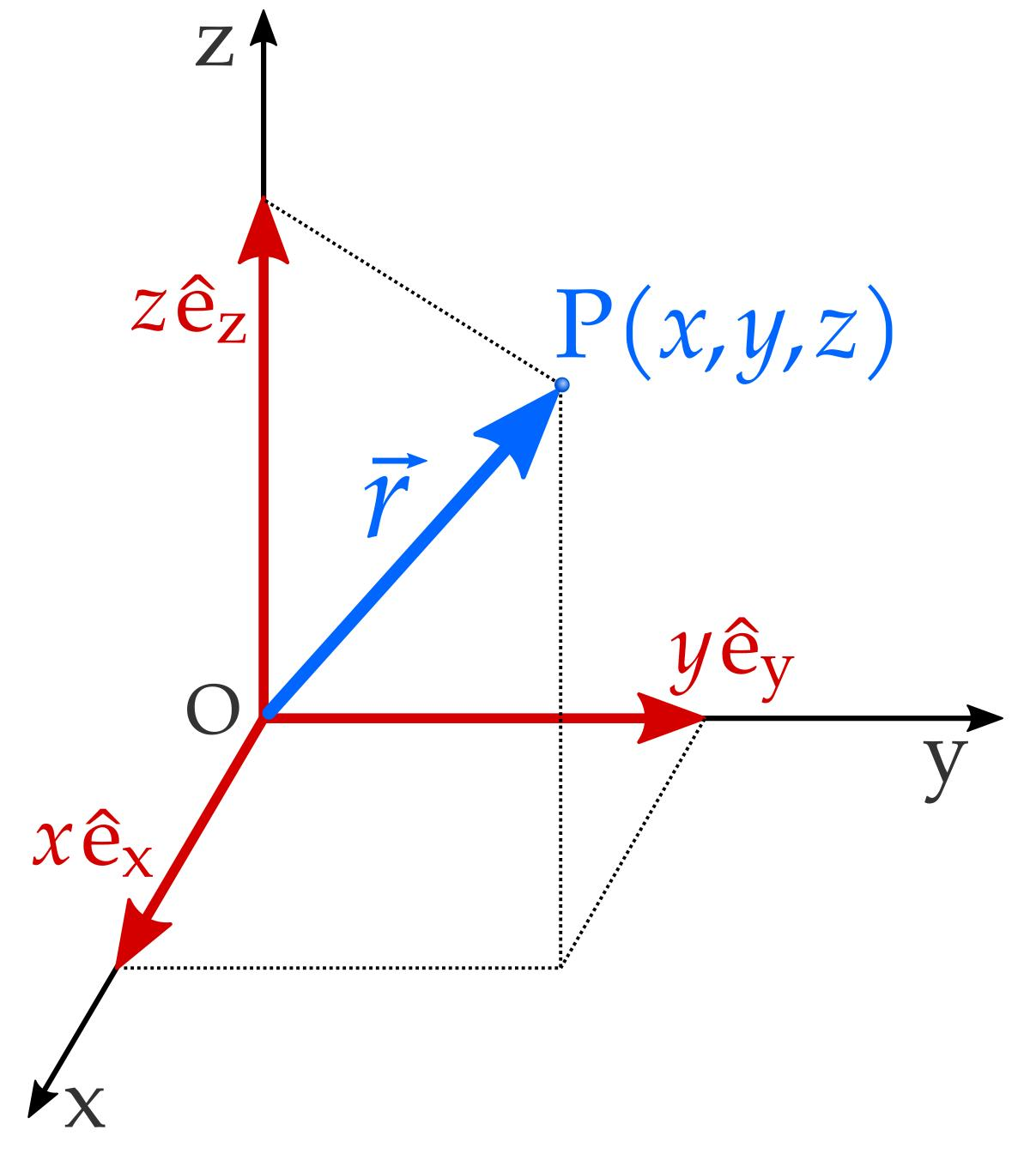
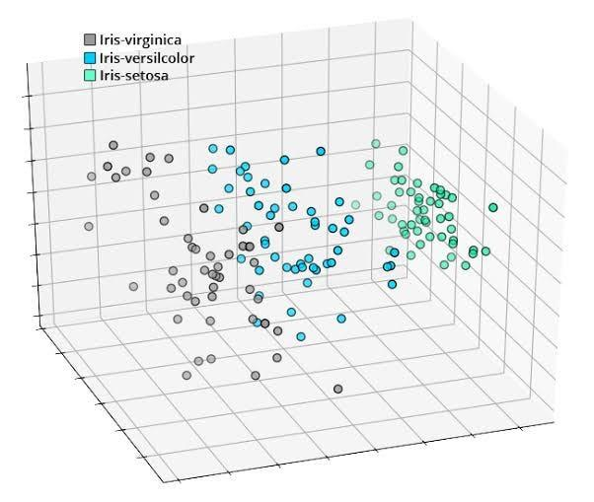
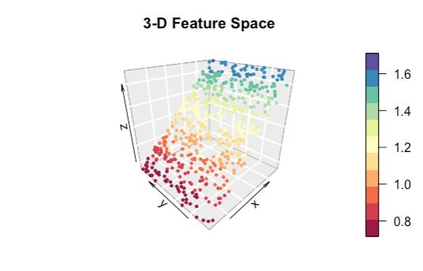
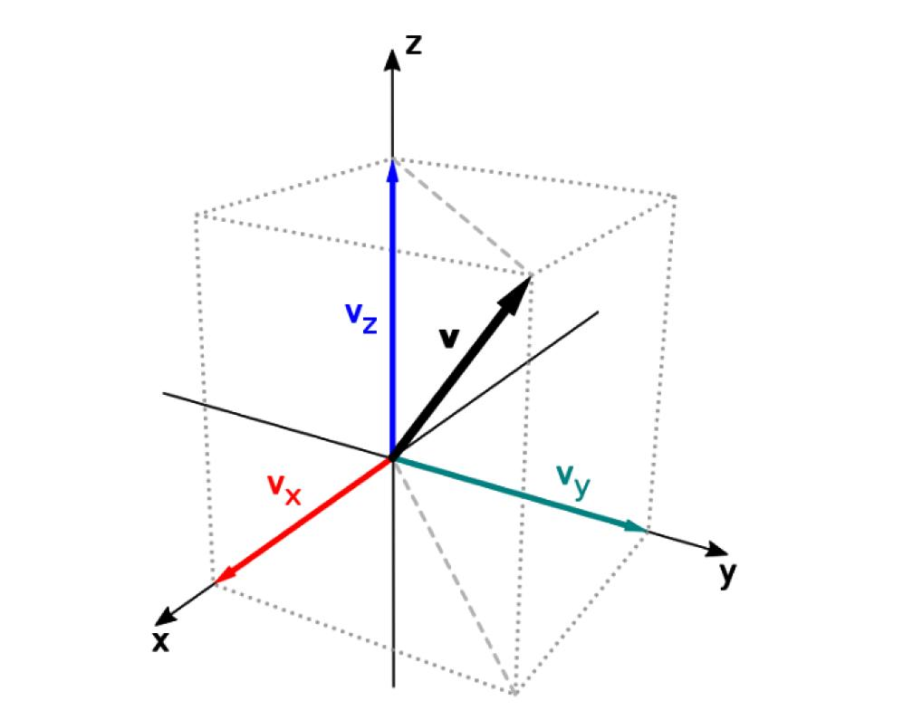
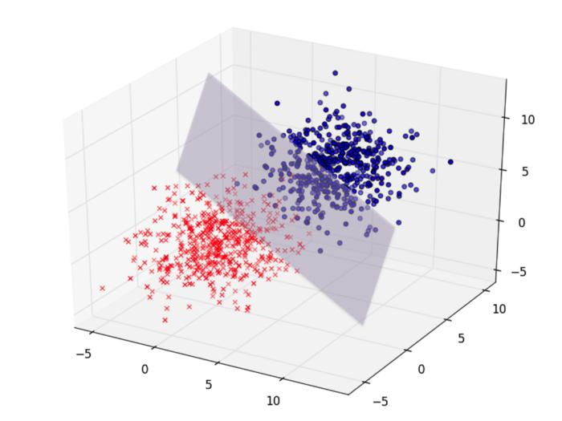
Humans can naturally visualize up to three spatial dimensions.
But data itself is not limited to three dimensions.
This distinction is extremely important.

9. Higher-Dimensional Data
Suppose a dataset has:
$$500\text{ features}$$
Then every observation can potentially be represented as a:
$$\boxed{500\text{-dimensional vector}}$$
We cannot directly visualize 500 dimensions.
But mathematically, we can still represent and manipulate the data.
This is one of the major strengths of linear algebra:
Linear algebra provides mathematical tools for working with high-dimensional data even when humans cannot directly visualize those dimensions.
The lecture specifically emphasizes that linear algebra works well with higher-dimensional data and can manipulate vectors/matrices even when there are hundreds or thousands of dimensions.

10. Dimensionality Reduction
Suppose we have:
$$500\text{ dimensions}$$
but we want to visualize the important structure of the data.
A technique called dimensionality reduction can transform the data into a lower-dimensional representation.
For example:
$$500D→2D$$
One important technique mentioned in the lecture is:
$$\boxed{\text{PCA — Principal Component Analysis}}$$
PCA uses concepts from linear algebra, including:
- Eigenvalues
- Eigenvectors
The detailed mathematics will come later in the course.
Why is this useful?
After reducing:
$$500D→2D$$
we can visualize the resulting data and potentially identify patterns or relationships.
The lecture specifically connects PCA with dimensionality reduction and eigenvalues/eigenvectors.
ML Importance: ⭐⭐⭐⭐⭐
PCA is an important example of how abstract linear algebra becomes a practical Data Science technique.

11. Quantifying Relationships Between Features
Consider two variables $X$and $Y$.
We may want to know:
- If $X$increases, does $Y$increase?
- If $X$increases, does $Y$decrease?
- If $X$decreases, does $Y$decrease?
- Is there some relationship between them?
For example:
$$X=\text{House Area} \\ Y=\text{House Price}$$
We may observe that as area increases, price generally increases.
The lecture refers to covariance and correlation as statistical concepts used to quantify such relationships. These will be studied more deeply later in Statistics.
Important distinction
Linear algebra helps us represent and manipulate the data.
Statistics then provides tools such as:
$$\boxed{\text{Covariance and Correlation}}$$
to quantitatively study relationships within that data.

12. Application 2 — Machine Learning and Artificial Intelligence
A major application of linear algebra is ML model training.
The lecture uses Linear Regression as an example.
Suppose:
- Input → house size
- Output → house price
We have many training observations:
$$\left(x_{1} , y_{1}\right),\left(x_{2} , y_{2}\right),…,\left(x_{n} , y_{n}\right)$$
We want to find a line that represents the relationship between $x$and $y$.
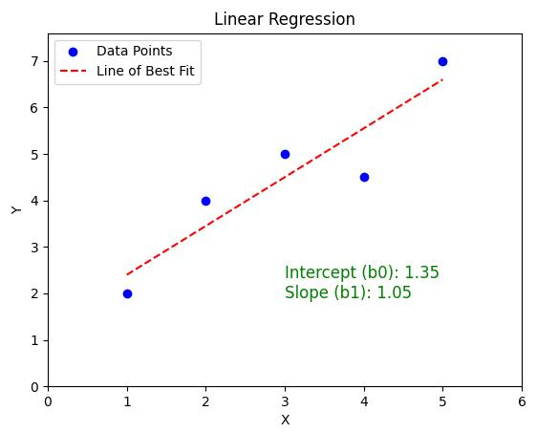
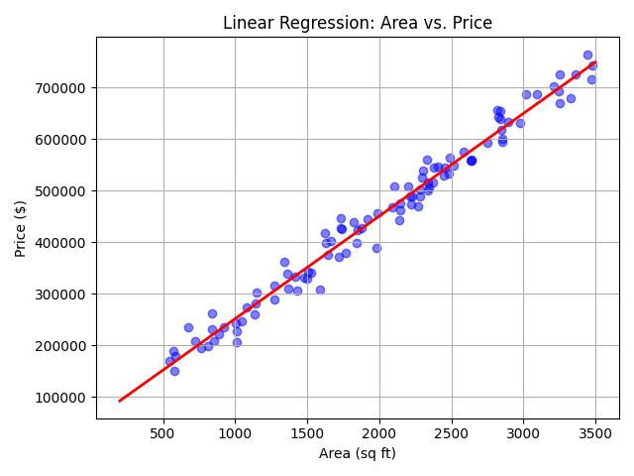
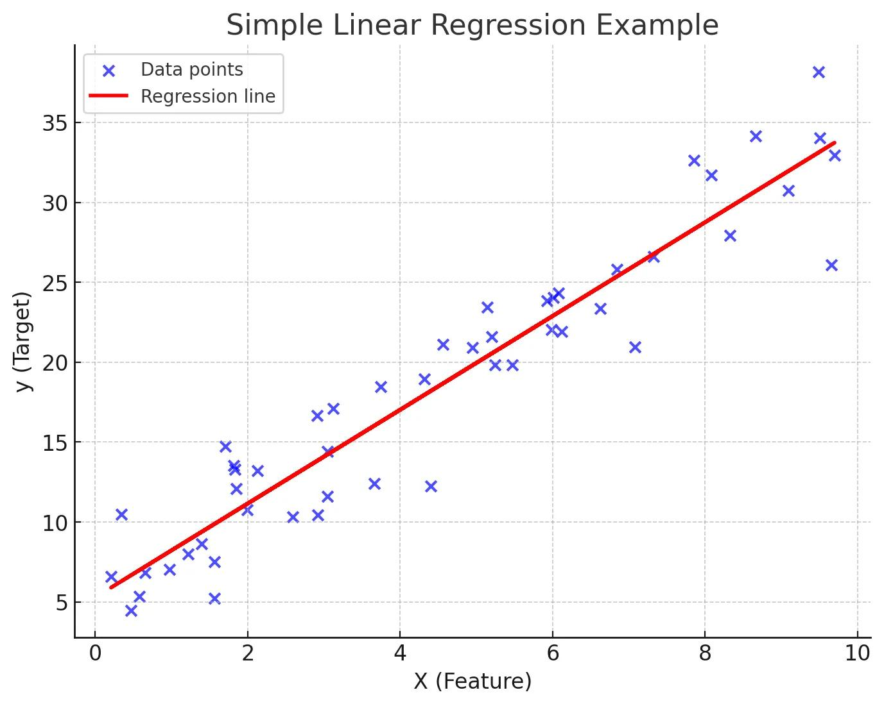
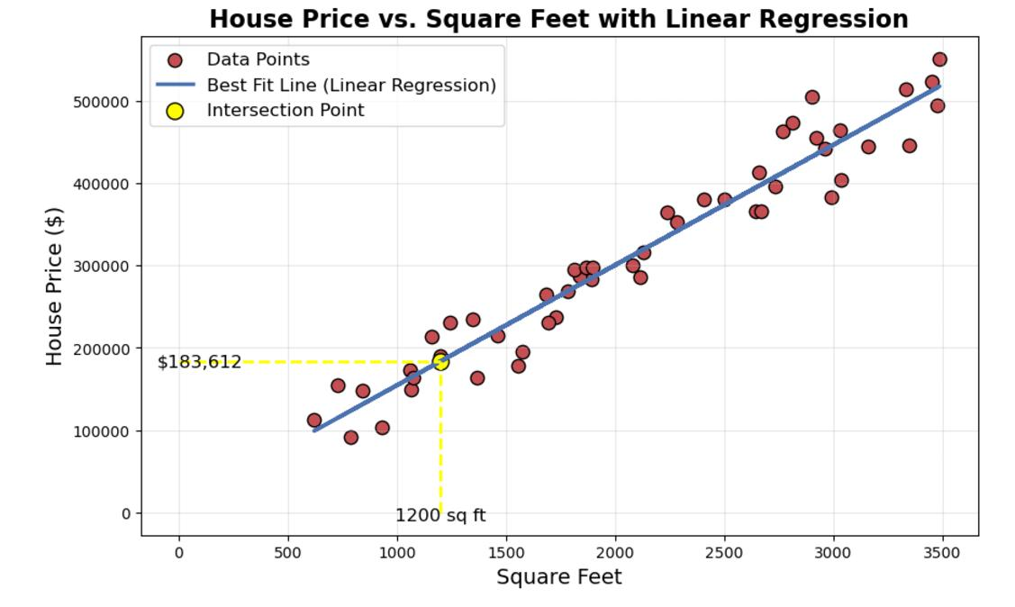
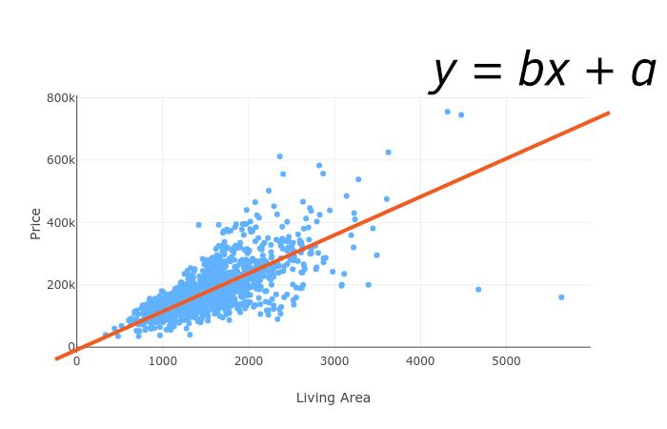

13. Equation of a Straight Line
The lecture introduces the equation:
$$\boxed{y=mx+c}$$
where:
- $x$= input
- $y$= output
- $m$= slope
- $c$= intercept
The equivalent general form is:
$$\boxed{ax+by+c=0}$$
These are examples of linear equations.
Understanding $y=mx+c$
Suppose:
$$y=2x+3$$
Here:
$$m=2$$
and
$$c=3$$
If:
$$x=1$$
then:
$$y=2\left(1\right)+3=5$$
If:
$$x=2$$
then:
$$y=2\left(2\right)+3=7$$
So the equation allows us to calculate the output based on the input.

14. Linear Regression and the Best-Fit Line
In a real dataset, the points usually do not lie perfectly on one straight line.
For example:
$$\left(1 , 2\right), \left(2 , 4\right), \left(3 , 5\right), \left(4 , 8\right)$$
We want to find a line that comes as close as possible to the observed points.
This is called the best-fit line.
The model needs to determine appropriate values of:
$$m$$
and
$$c$$
so that the resulting line provides good predictions.
The lecture explains this in the context of predicting house price from house size.

15. Error and Best Fit
For every actual data point, the model produces a prediction.
For example:
$$\text{Actual Price}=50 \\ \text{Predicted Price}=47$$
The prediction error is related to the difference:
$$50-47=3$$
For many observations, we have many errors.
The goal is to choose the model parameters so that the overall error is sufficiently small.
Therefore:
Good model → predictions close to actual values → small error
This leads us to optimization.

16. Application 3 — Optimization
What is optimization?
Optimization is the process of finding parameter values that give us the desired result.
In ML, this commonly means:
Find model parameters that minimize the model's error/loss.
For linear regression:
$$y=mx+c$$
we need to find appropriate values of:
$$m, c$$
The lecture describes this as finding the slope and intercept that produce the best-fit line by minimizing the error.
Important idea
We are not randomly choosing $m$and $c$.
Instead, we define an objective/error function and systematically search for parameter values that improve it.

17. Gradient Descent
The lecture introduces Gradient Descent as an important optimization technique and refers to it as an optimizer.
You do not need the full mathematics yet.
For now, remember:
Gradient Descent is an optimization algorithm used to update model parameters so that the error/loss decreases.
A simplified conceptual flow is:
$$\boxed{\text{Model}→\text{Calculate Error}→\text{Gradient}→\text{Update Parameters}→\text{Lower Error}}$$
Later, differential calculus will explain why the gradient tells us how to update the parameters.
Key Connection
$$\boxed{\text{Derivatives}→\text{Gradients}→\text{Gradient Descent}→\text{Optimization}→\text{Model Training}}$$
This connection will become extremely important when you study ML and Deep Learning.

18. Application 4 — Dimensionality Reduction
As discussed earlier, datasets can have many dimensions.
For example:
$$500\text{ features}$$
can make direct visualization difficult.
Dimensionality reduction attempts to represent the important information using fewer dimensions.
The lecture specifically connects:
$$\boxed{\text{PCA}→\text{Linear Algebra}→\text{Eigenvalues + Eigenvectors}}$$
and uses PCA as an example of reducing higher-dimensional data into lower-dimensional data.
Example
$$500D→2D$$
The purpose is not simply "throw away dimensions."
The goal is to create a lower-dimensional representation that retains useful information/patterns from the original data.
Detailed PCA mathematics will come later.
ML Importance: ⭐⭐⭐⭐⭐
Very important for understanding:
- Feature reduction
- Visualization
- Data compression
- Some preprocessing workflows

19. Application 5 — Neural Networks and Deep Learning
Linear algebra becomes even more important in neural networks.
A neural network contains:
- Input neurons
- Hidden neurons
- Output neurons
- Weights
- Biases
The lecture gives an example with:
- 2 input features
- 3 hidden neurons
- 1 output
The inputs could be:
$$F_{1}=\text{Area} \\ F_{2}=\text{Number of Rooms}$$
and the output could be:
$$\text{Price}$$

20. Neural Network Weights as a Matrix
Suppose we have two input features:
$$F_{1},F_{2}$$
and three hidden neurons.
There will be six weights connecting the inputs to the hidden layer.
They can be organized into a matrix such as:
$$W=\left[\begin{matrix}w_{1} & w_{2} & w_{3} \\ w_{4} & w_{5} & w_{6}\end{matrix}\right]$$
This is a:
$$\boxed{2×3}$$
matrix.
The lecture explicitly uses this example to show that neural-network weights can be represented using matrices.

21. Matrix Multiplication in Neural Networks
The input can be represented as a vector:
$$x=\left[\begin{matrix}F_{1} \\ F_{2}\end{matrix}\right]$$
and the weights are represented as a matrix.
The fundamental operation is then matrix multiplication.
Conceptually:
$$\boxed{\text{Input}×\text{Weights}→\text{Output of a Layer}}$$
A bias is also added.
A simplified representation is:
$$\boxed{z=xW+b}$$
depending on the orientation/convention used for the vectors and matrices.
The important idea at this stage is not the exact neural-network architecture but this:
A neural network performs large numbers of matrix and vector operations.
The lecture identifies matrix multiplication and addition of biases as fundamental operations during forward propagation.
ML Importance: ⭐⭐⭐⭐⭐
This is one of the most important reasons you need linear algebra for Deep Learning.

22. Forward and Backward Propagation
Two important neural-network processes mentioned in the lecture are:
Forward Propagation
Information moves:
$$\boxed{\text{Input}→\text{Hidden Layers}→\text{Output}}$$
During this process, matrix operations are heavily used.
Backward Propagation
The model calculates how its parameters should be updated based on the error.
The lecture connects this to the chain rule of derivatives, which will be covered under differential calculus.
This gives an important mathematical connection:
$$\boxed{\text{Linear Algebra}+\text{Calculus}→\text{Neural Network Training}}$$

23. GPUs and Parallel Matrix Computation
Modern neural networks perform enormous numbers of mathematical operations.
GPUs are useful because they contain many computational cores that can perform operations in parallel.
The lecture connects this specifically to the large amount of matrix multiplication involved in neural-network training.
Conceptually:
$$\text{Neural Network}→\text{Many Matrix Operations}→\text{Parallel Computation}→\text{GPU}$$
This is one reason linear algebra is not merely theoretical: efficient matrix computation is fundamental to modern AI systems.

24. Tensors
The lecture also mentions TensorFlow and tensors.
In modern ML, numerical data can have more than two dimensions.
For example:
- Scalar → 0D
- Vector → 1D
- Matrix → 2D
- Higher-dimensional array → tensor
The lecture's main point here is that neural-network computations involve tensor representations and that these computations can be efficiently executed on GPUs.
For now, don't worry about the full mathematical definition of a tensor. That will become clearer when you study Deep Learning.

25. Application 6 — Computer Graphics and Images
Linear algebra is also heavily used in computer graphics.
An image can be represented numerically using pixels.
For an RGB image, each pixel contains information for:
- Red
- Green
- Blue
Each channel typically contains values such as:
$$0\text{ to }255$$
The lecture illustrates an RGB image as a multi-dimensional numerical representation.

26. Image Transformations
Once an image is represented numerically, mathematical operations can be applied to it.
For example:
Scaling
Change the size of an image.
Rotation
Rotate the image.
Translation
Move the image/object from one location to another.
Grayscale / Black and White
Transform the representation so that color information is removed/reduced.
These transformations can be expressed using mathematical operations from linear algebra.
The lecture specifically identifies scaling, rotation, and translation as examples of transformations in computer graphics.
Key idea
$$\boxed{\text{Image}→\text{Numerical Representation}→\text{Linear Algebra Operations}→\text{Transformed Image}}$$

27. 3D Graphics
Linear algebra is also useful when working with three-dimensional objects.
For example:
$$\text{3D Model}→\text{2D Image}$$
A 3D object needs to be transformed/projected so that it can be represented on a 2D screen.
The lecture mentions this as another application of linear algebra in computer graphics.

28. The Bigger Picture: Why Linear Algebra Is a Foundation
The lecture's main message is that linear algebra is a building block for many techniques encountered later in ML and AI.
Think of the mathematical foundation as interconnected rather than isolated:
LINEAR ALGEBRA
│
┌───────────────┼────────────────┐
│ │ │
Vectors Matrices Linear Equations
│ │ │
│ │ │
Data Neural Regression
Representation Networks
│ │
│ │
Embeddings Deep Learning
│
Matrix Operations
│
GPUs

Linear Transformations
│
PCA
│
Dimensionality Reduction
│
Eigenvalues/
Eigenvectors

Optimization
│
Gradient Descent
│
Model Training
This is the conceptual map you should keep in mind while progressing through the course.

Important Formulas
1. Equation of a Straight Line
$$\boxed{y=mx+c}$$
Where:
- $y$= output/dependent variable
- $x$= input/independent variable
- $m$= slope/coefficient
- $c$= intercept

2. General Form of a Linear Equation
$$\boxed{ax+by+c=0}$$
The exact interpretation of the coefficients depends on the equation and context.

3. Basic Neural-Network Linear Operation
Depending on whether vectors are represented as rows or columns:
$$\boxed{z=xW+b}$$
or equivalently under another convention:
$$\boxed{z=Wx+b}$$
The important concept is:
$$\boxed{\text{Input × Weights + Bias}}$$

Common Mistakes / Confusions
1. Dimension ≠ Physical Space
A 500-dimensional vector does not mean we need to physically visualize 500 spatial axes.
It simply means the vector contains 500 components/features.

2. Number of Features vs Vector Dimension
If one observation has:
$$\left[x_{1} , x_{2} , x_{3} , x_{4}\right]$$
then it is a:
$$\boxed{4\text{-dimensional vector}}$$
because there are four components.

3. A Vector Is Not Necessarily a Physical Arrow
In introductory mathematics, vectors are often visualized as arrows.
In Data Science, vectors are frequently used simply as numerical representations of observations/features.
For example:
$$\left[25 , 50000 , 3\right]$$
could represent features such as age, income, and years of experience.

4. Don't Confuse a Matrix With a Vector
A vector is generally one ordered collection of components.
A matrix contains values arranged into rows and columns.
For example:
$$x=\left[\begin{matrix}2 \\ 4 \\ 6\end{matrix}\right]$$
is a vector, while
$$X=\left[\begin{matrix}2 & 4 \\ 6 & 8 \\ 10 & 12\end{matrix}\right]$$
is a matrix.

5. Optimization Does Not Mean Simply "Finding Any Solution"
In ML, optimization generally means finding parameter values that optimize an objective, commonly by minimizing loss/error.

6. Slope vs Intercept
For:
$$y=mx+c$$
remember:
$$\boxed{m=\text{slope}} \\ \boxed{c=\text{y-intercept}}$$
The lecture briefly calls $m$a "coefficient" as well, which is fine, but slope is the more specific interpretation in the straight-line context.

Important Conceptual Connections
Connection 1: Data → Vectors
$$\boxed{\text{Dataset Features}→\text{Numerical Representation}→\text{Vectors}}$$
ML models need numerical representations to perform mathematical calculations.

Connection 2: Many Vectors → Matrices
When many observations/vectors are organized together, they can be represented using a matrix.
Conceptually:
$$\boxed{\text{Individual observations}→\text{Vectors}→\text{Dataset Matrix}}$$
This becomes extremely important when you start performing matrix operations in ML.

Connection 3: Linear Algebra → Regression
$$\boxed{y=mx+c→\text{Find }m,c→\text{Best Fit}→\text{Minimize Error}}$$

Connection 4: Linear Algebra + Calculus → Deep Learning
$$\boxed{\text{Matrix Operations}+\text{Derivatives}→\text{Neural Network Training}}$$

Connection 5: Linear Algebra → PCA
$$\boxed{\text{High-Dimensional Data}→\text{PCA}→\text{Lower-Dimensional Representation}}$$
with:
$$\boxed{\text{Eigenvalues + Eigenvectors}}$$
playing an important role.

How This Connects to Data Science
The entire lecture can be summarized through the following pipeline:
Step 1 — Represent the data
Real-world information is converted into numerical features.
$$\text{Real-world data}→\text{Numerical features}$$
Step 2 — Represent features using vectors
$$\text{Features}→\text{Vectors}$$
Step 3 — Organize data using matrices
$$\text{Many vectors}→\text{Matrices}$$
Step 4 — Perform mathematical operations
$$\text{Vectors + Matrices}→\text{Calculations}$$
Step 5 — Train ML models
Linear equations and matrix operations help models learn relationships.
Step 6 — Optimize
Optimization techniques such as gradient descent help find better model parameters.
Step 7 — Apply to advanced AI
The same mathematical foundation appears in:
- Neural Networks
- Deep Learning
- NLP
- Embeddings
- Computer Vision
- PCA
- Modern AI systems

Quick Revision
Core Ideas
- Linear algebra is a foundational mathematical tool for Data Science, ML, and AI.
- It focuses on concepts such as vectors, vector spaces, matrices, linear transformations, and linear equations.
- Data Science represents many types of data numerically.
- A collection of feature values for one observation can be represented as a vector.
- Number of features = dimension of the feature vector.
- Linear algebra allows us to work with high-dimensional data even when we cannot visualize it.
- PCA can reduce high-dimensional data to lower dimensions and uses eigenvalues/eigenvectors.
- ML model training involves many mathematical operations, including matrix operations.
- Neural networks heavily rely on matrix multiplication and addition.
- Gradient descent is an optimization technique used to reduce model error/loss.

Key Formulas
$$\boxed{y=mx+c}$$
Equation of a straight line.
$$\boxed{ax+by+c=0}$$
General form of a linear equation.
$$\boxed{z=xW+b}$$
Basic form of a neural-network linear operation under one common vector convention.

Key Connections to Remember
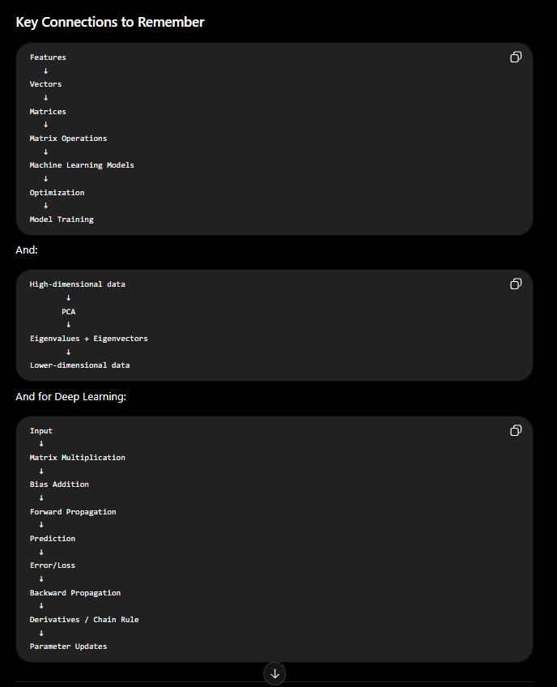

What You Should Be Able to Explain
After this lecture, you should be able to answer:
- What is linear algebra?
- Why is linear algebra important for Data Science and ML?
- What is a scalar?
- What is a vector?
- What does the dimension of a vector mean?
- How can a house-price observation be represented as a vector?
- Why can ML models not directly work with concepts such as "Bangalore" or "house"?
- Why is high-dimensional data difficult for humans to visualize?
- What is dimensionality reduction?
- What is PCA used for?
- What are eigenvalues and eigenvectors used for in the context introduced here?
- How is $y=mx+c$related to linear regression?
- What are slope and intercept?
- What is a best-fit line?
- Why is optimization required during model training?
- What is gradient descent?
- Why does a neural network need matrix multiplication?
- What are forward and backward propagation at a high level?
- Why are GPUs useful for deep-learning computations?
- How can linear algebra be used in computer graphics?
One sentence to remember
Linear algebra gives ML and Data Science a mathematical language for representing data as vectors/matrices and efficiently performing the transformations and computations required to learn from that data.
This first lecture is mainly a roadmap and motivation for linear algebra rather than a deep mathematical treatment. The detailed mathematics of scalars, vectors, matrices, matrix operations, linear transformations, eigenvalues, and eigenvectors is intended to come in the subsequent lectures.

